Collecting Audience In-Market Segments Through Google Analytics

Website/SEO Assignments

NAME: Tahiya Rahman

horizontal line

# About the Data

The purpose of the paper is to collect the findings from the user acquisition, user behavior and user conversion rate data to understand the trend and user influences in NSTEM website. The data are somewhere shown steady and somewhere it shows a fast pace. There are metrics which are creating leads and each has significant importance in different ways.

# Comparison of Data over Different Time Periods

March 26th, 2023 - April 2nd, 2023

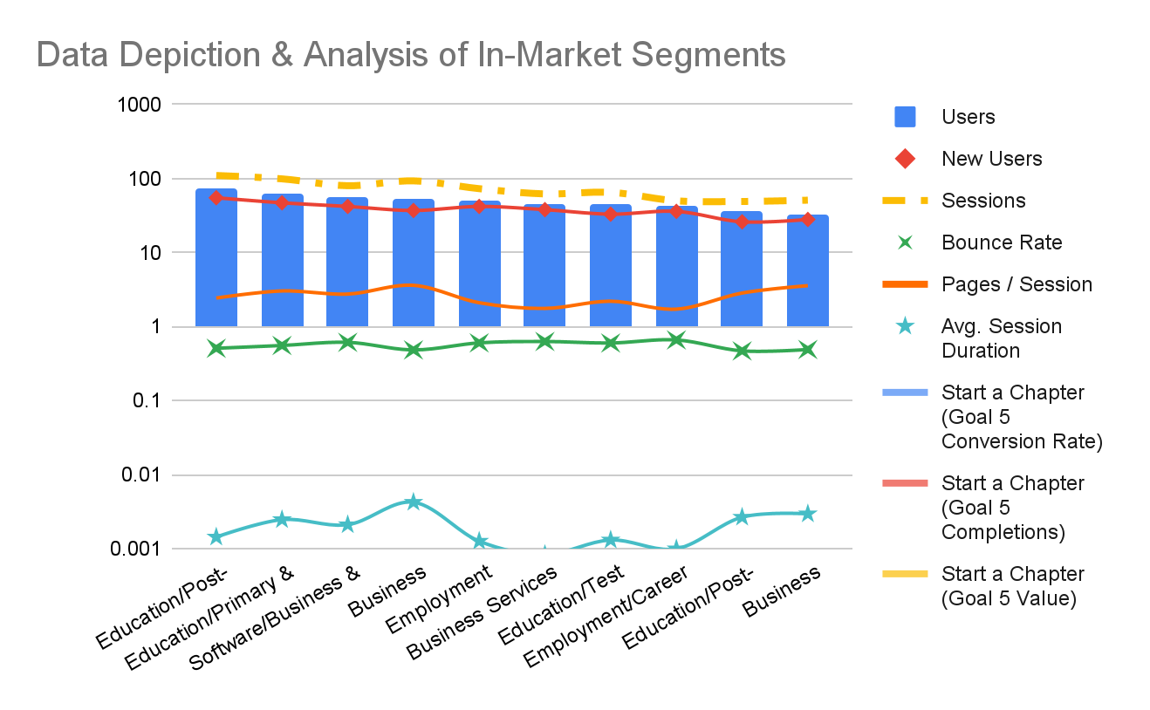

* Education/Post-Secondary education shows the higher interest, on the other analysis with the source/mediums data showing a different result where the chapter completion rate is higher and which shows a good correlation and proves the credibility for the analysis.
* With a correlated view, data showed a decent increase in users and new users within the sessions for all the metrics.

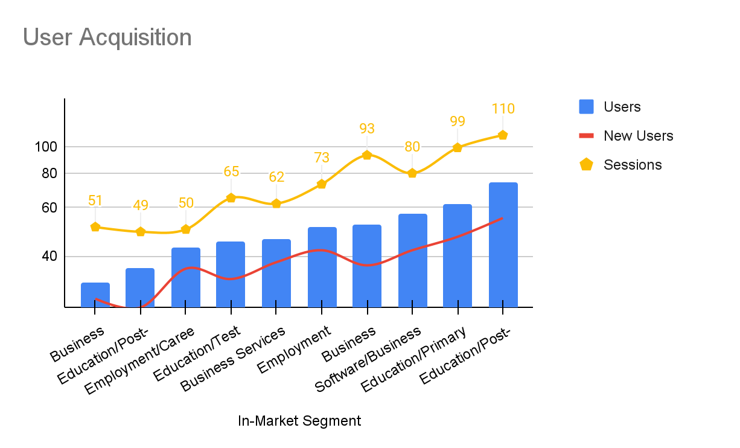

* User acquisition, showed a similar trend for the session with the users that Higher secondary and also other metrics get increased by a decent number.

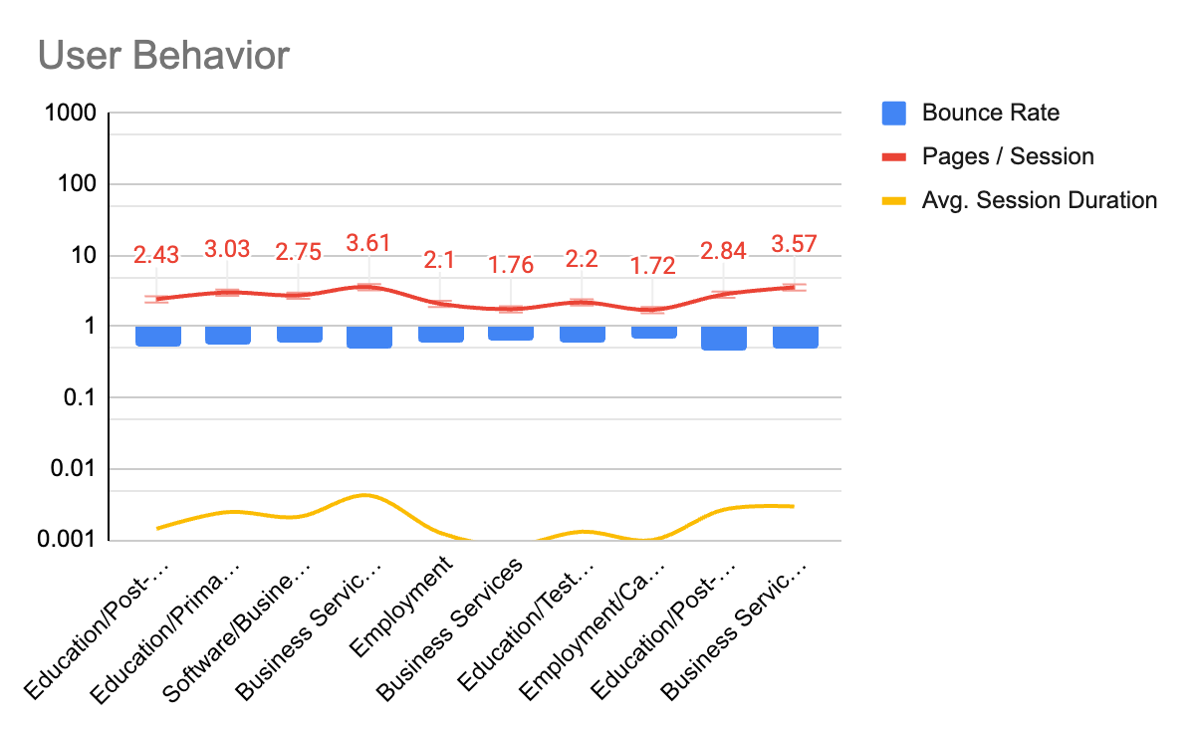

* From user behavior, the metrics are under performing but there is still scope for improvement. By looking at the bounce rates, the data has been observed as a good performer because it's been aligned with the trendline.

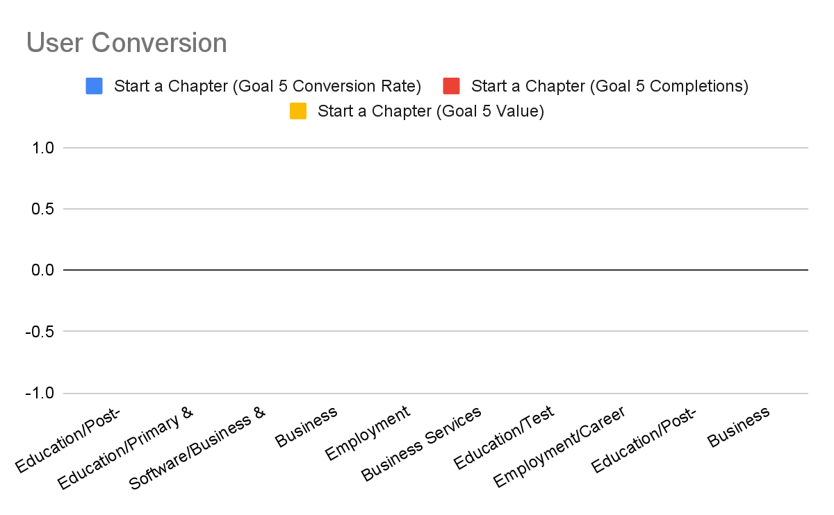

* The conversion rate shows all shows at no result values. But this can not be the considered result for the user conversion. Because the goal was to achieve a good session with new users rate which has been achieved already with the user acquisition and user behavior.

# Users by days

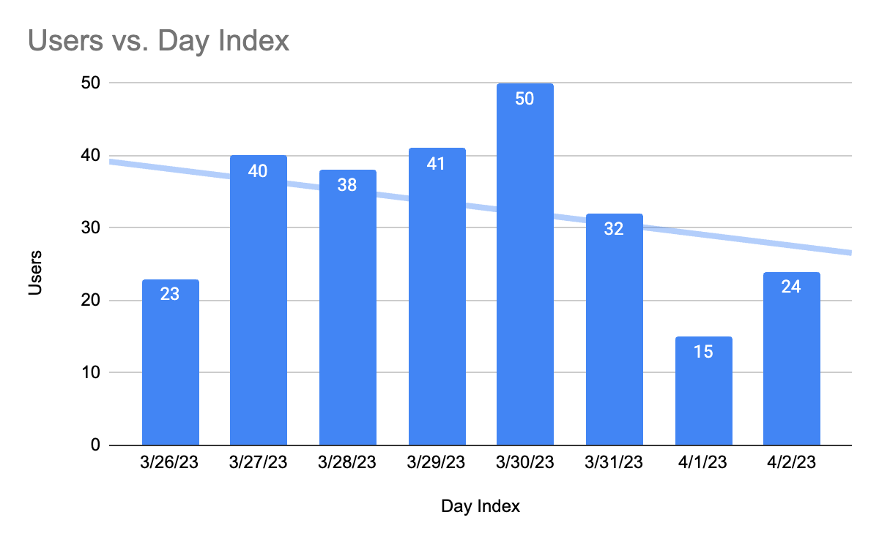

* From the Day index, most traffic was generated on 30th March.

# What NSTEM Should Continue Doing

* NSTEM should continue promotion for the higher secondary schools and increase exposure to the schools where they will be able to find more leads.

# Ways to Improve the Website

* NSTEM can introduce different project books with creative banners and interactive plays for the students in higher secondary. So students will be able to understand and get to know NSTEM more.

# Data that Stands Out

From the analysis, the data stood out as the Business services which seems to be a potential scope to give attention, because it has the lowest bounce rate and a steady, decent amount of users, new users and session average. .

# Conclusion

To conclude, the overall data shown that the users has interest in each sector of metrics and in the market segment has been growing since last year from a thorough data observation.